# Hans Alberto Franke

## Spatial Data Analysis

## Date: 30/11/2020

# Assignment:

## Topic definition:

Looking in the database to decide which kind of land use type I would be motivated to use, I filter all unique rows (with English words side by side!).

**Dataset**: GRONDGEBRUIK_2017_RDNew.shp

**Excel**: 

Some examples:

|  |  |  |  |  |
| --- | --- | --- | --- | --- |
| AMScode | AMScode_Om | AMScode__1 | CBScode2 | CBScode2_O |
| 101 | Spoorterrein | Train-railway area | 10 | Spoorterrein |
| 102 | Metro, vrije trambanen | Metro-, free tramrail | 10 | Spoorterrein |
| 103 | Bedrijfsspoor | Railway at production site, harbour etc. | 10 | Spoorterrein |
| 110 | Wegverkeersterrein | Mainroad system, paved roads | 11 | Wegverkeersterrein |
| 111 | Wegverkeersterrein rijkswegen | Highways | 11 | Wegverkeersterrein |
| 112 | Wegverkeersterrein provinciale wegen | Regional ways (county; provinces) | 11 | Wegverkeersterrein |
| 120 | Vliegveld (NIET het gras!!) | Airport (not the grass lands) | 12 | Vliegveld |
|  |  |  |  |  |

When reading all the cool stuffs that the dataset, I decided for: the lakes very near of Amsterdam.

|  |  |  |  |  |
| --- | --- | --- | --- | --- |
| AMScode | AMScode_Om | AMScode__1 | CBScode2 | CBScode2_O |
| 700 | IJsselmeer/Markermeer | IJselmeer (lakes very near to Amsterdam) | 70 | IJsselmeer/Markermeer |

As I enjoy spend time in lake areas (even with this dutch weather), I thought to analyze which region of Amsterdam is closest in the average to lake areas.

## Loading initial map

To load the areas of lakes, first we need to change in our model the attribute (from 40 = Parks, to 70 = lake areas)

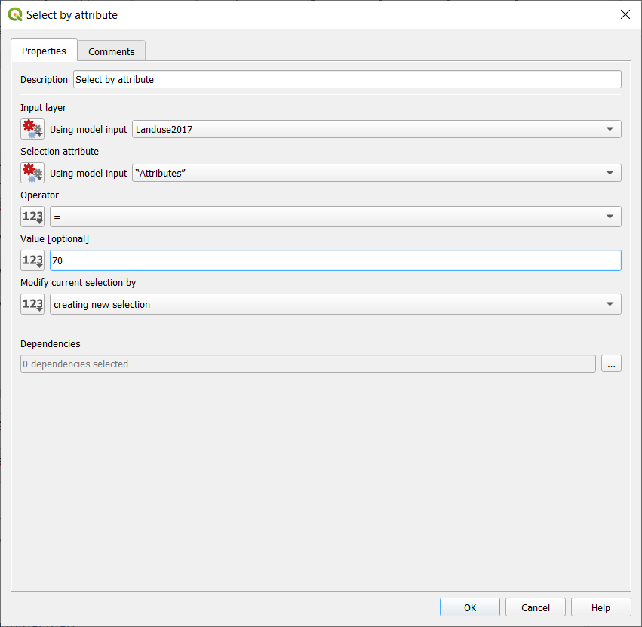

The map below is the project map of regions (delimited with red borders), and blue squares of 40x40 each, representing the lakes. I chose use google normal at background just to give some context to where we are.

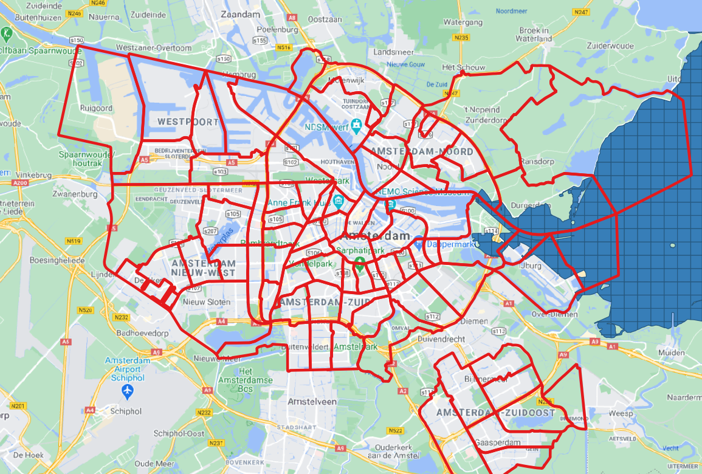

I had to save the PC4, to a new name just to input the new fields, and don’t mess with the tutorial files.

As expected just a few regions have distance to lake calculated.

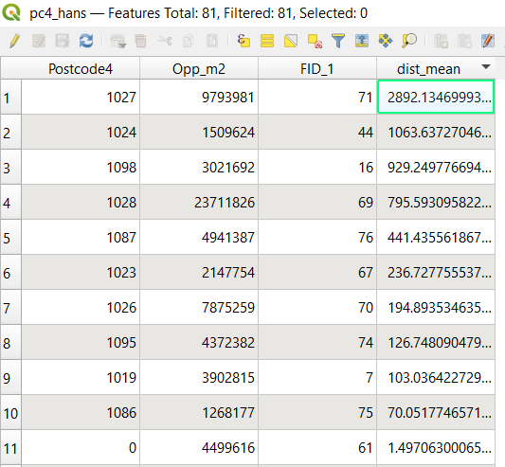

After classifying the regions by distance (granulated, or choropleth map), I decided for just 3 colors, representing: close, medium and faraway. Thus, the color is strong in regions closer to the lakes.

## Final Map Projection

We can see that the closest distance are with dark green colors (the dark blue is region area that overlap lakes areas), and far areas with white. The distance is the mean distance between region and lake areas. The numbers in maps are the postcodes of regions, just to made more visual.

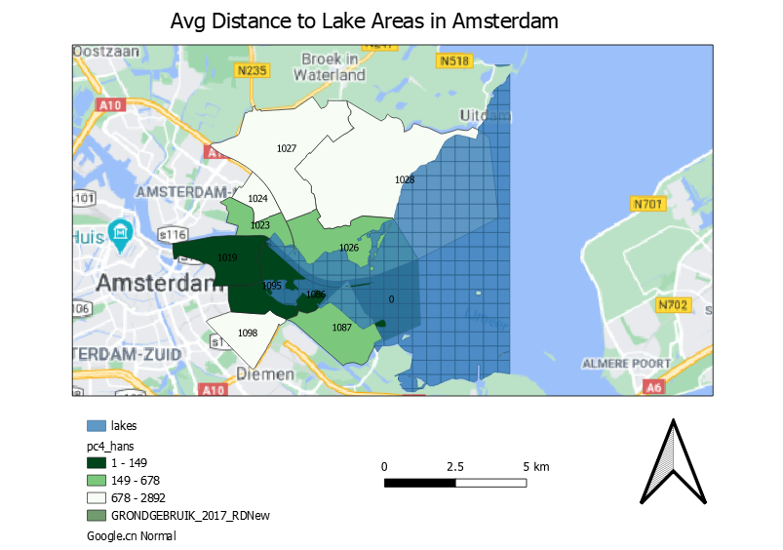

## Python Script

**Filename**: model_assigment.py

Link: [Assigment\model_assigment.py](Assigment/model_assigment.py)

## Model Design

**Filename**: Distance_Assigment.model3

